A Project Report

ON

Crowd Funding Platform

By- Kashyap Patel (1995569)

Nisarg Patel (1994868)

Zeel Trivedi (1993983)

Harshil Patel (1993498)

**Contents**

|  |  |
| --- | --- |
|  |  |
|  |  |
| Introduction | 3 |
| Purpose | 3 |
| Scope | 3 |
| Functional Requirements | 4 |
| Non-Functional Requirements | 4 |
| Scree Flows  Conclusion | 5  12 |

**Introduction**

We believe every idea is important because you may never know your next idea could change the world for the better. Your idea may be a great one but what if no one knows about it or ready to support it? Don’t worry. We have created a platform where you can share your ideas with others. We can help you raise awareness or charity for it.

**Purpose**

The purpose of this platform is to help creators raise funds and awareness for their new projects and ideas. This platform will host a bunch of Investors as well as people who have new ideas. Participants post their project with the target fund on a platform and investors will decide if they want to support their project financially or not.

**Scope**

Scope of this project includes:

1. Post Projects Area
2. View Projects Area
3. Fund Projects Area
4. Admin Area
5. Login Area
6. Signup Area

**Functional Requirement**

|  |  |  |  |
| --- | --- | --- | --- |
| **ID** | **Module** | **Severity** | **Description** |
| FR001 | Login | HIGH | User should be able to login |
| FR002 | SignUp | HIGH | User should be able to sign up |
| FR003 | LogOut | MEDIUM | User should be able to logout from the account |
| FR004 | Projects (Project List) | MEDIUM | User should be able to see all the posted projects |
| FR005 | Projects (New Project) | MEDIUM | User should be able to post new project from his account |
| FR006 | Projects (Delete Project) | MEDIUM | User should be able to delete posted project |
| FR007 | Account | MEDIUM | User should be able to access all his account details and projects posted by user |
| FR008 | Admin (Projects List) | HIGH | Admin should be able to see all the projects |
| FR009 | Admin (Fund Project) | HIGH | Admin should be able to fund any project |
| FR010 | Admin (Delete Project) | HIGH | Admin should be able to delete any project |
| FR011 | Admin (Users List) | HIGH | Admin should be able to see all users |
| FR012 | Admin (Delete User) | HIGH | Admin should be able to delete any user |

**Non-Functional Requirement**

|  |  |  |  |
| --- | --- | --- | --- |
| **ID** | **Module** | **Severity** | **Description** |
| NFR001 | Performance | MEDIUM | The website should load fast |
| NFR002 | Scalability | MEDIUM | The website should scale horizontally when more users are online |
| NFR003 | Security | MEDIUM | The website login and signup should be secure |
| NFR004 | Copyright Content Protection | MEDIUM | Platform should be able to provide copyright content protection for users with original and unique ideas |

**Screen Flows**

Home Screen

Contact Us.

Log IN

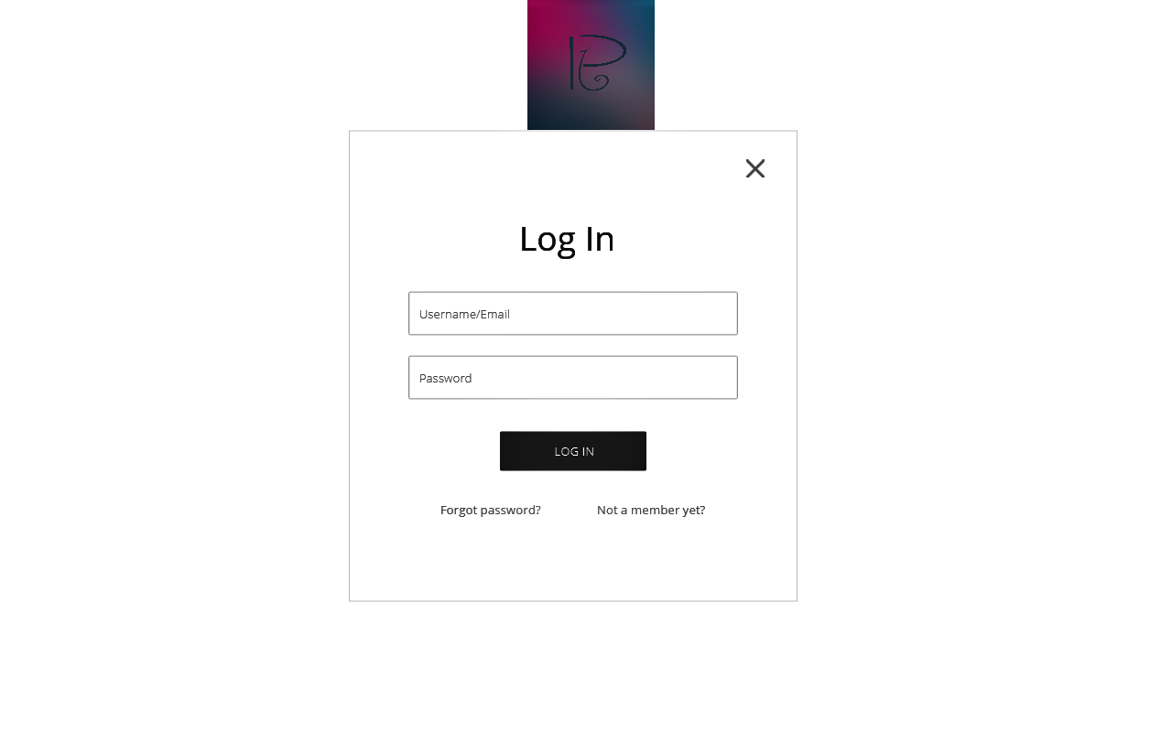

Registration.

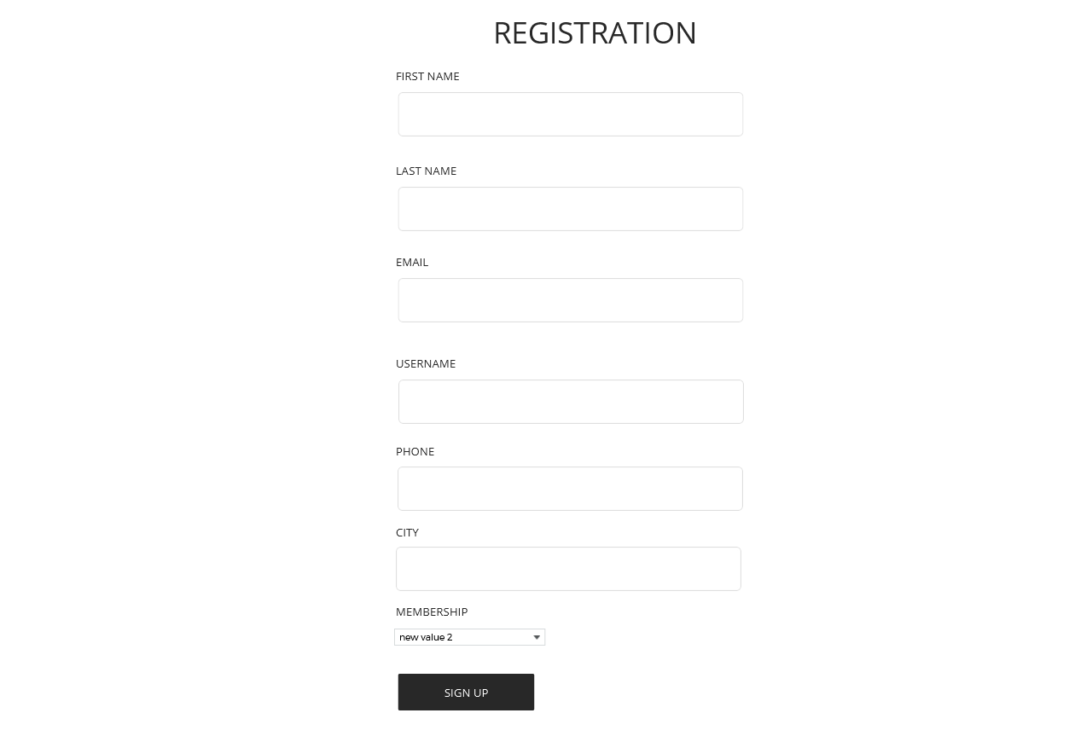

Submit project.

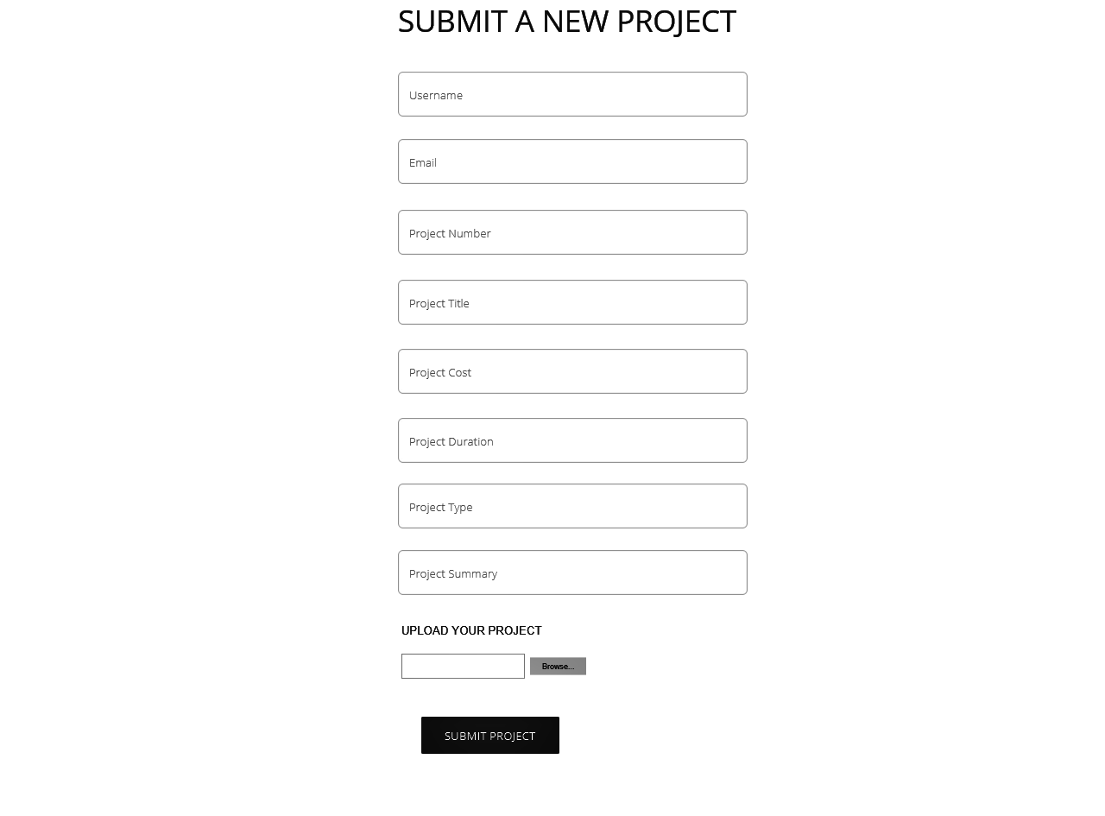

View Projects.

About Us.

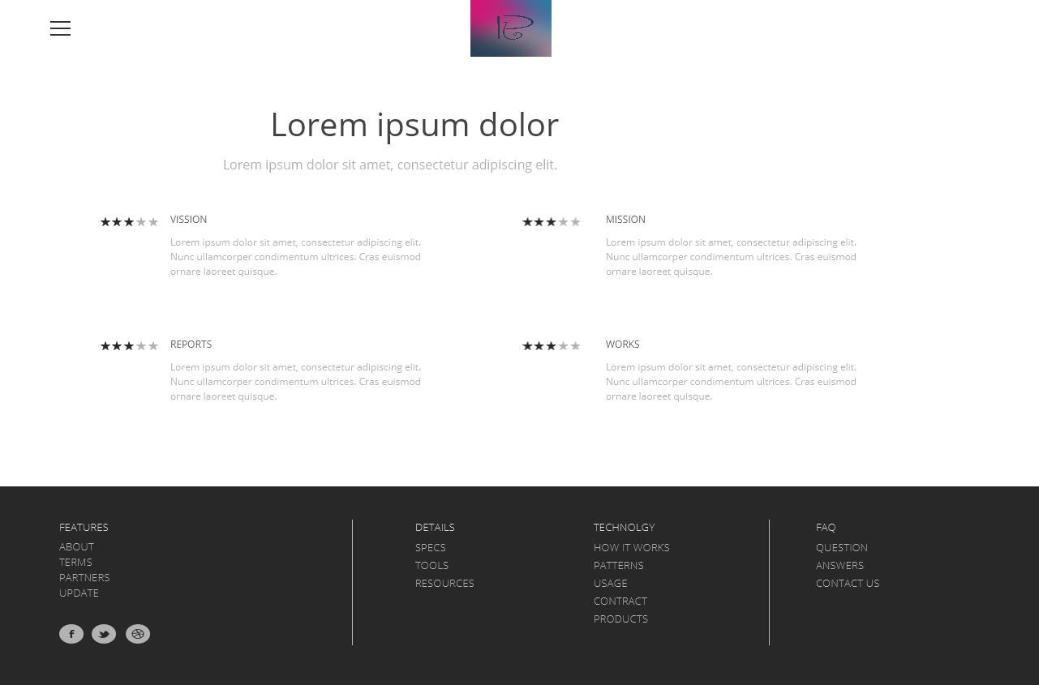

**Conclusion:**

So to conclude the overall project, it is a web based application where a user or a client can upload their projects, view different projects, update and delete their existing projects. It is necessary to log in into the application to view the whole application. The admin can approve the projects before putting them live on the website. The client can contact the admin very easily. The queries and problems of any client is solved when it is uploaded in contact us page. The information about the application is mention in the About Us page for the details.